Accessible Coffee Beans Images

Accessible Espresso Beverages

Espresso shot pouring down from the machine.

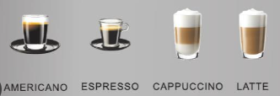

Pumpkin spice latte



To Be continued